Wavelet correlation and coherence: GBPUSD and EURGBP
Method 22 / daily log returns / Morlet CWT / Alpari D1 full available history

Study setup
Logical pair: GBPUSD , EURGBP
Broker symbols: GBPUSD_i , EURGBP_i
Snapshot: 2026-11-03_majors_alpari_D1
Timeframe: D1
Matched return window: 1999-01-06 to 2026-11-02 (UTC bar dates)
Matched return count n: 7199
Dropped unfinished last bar dated 2026-11-03 UTC after a tick-volume check against the prior complete day.
Wavelet: morl; center freq=0.8125; periods=[5, 21, 63]
Headline: rho_wavelet at 21 trading days
Complete matched rows (Excel): GBPUSD-EURGBP_Wavelet_D1.xlsx
Complete matched rows (HTML table): GBPUSD-EURGBP_Wavelet_D1_data.html

Method carried forward
Wavelet correlation rho_wavelet(s) and local coherence R^2(s,t) measure scale-localized linkage of matched daily log returns of close, ln(close_t / close_t-1). Quotes are not inverted. Continuous wavelet transform uses PyWavelets Morlet ('morl') with center frequency 0.8125; scale = 0.8125 * period_days for pre-specified periods {5, 21, 63}. rho_wavelet is Pearson correlation of demeaned real coefficients at that scale. R^2(s,t) uses a Gaussian smoother in time only (sigma = max(period/4, 2)); mean R^2 drops points within one scale of each edge (cone of influence). Headline is signed rho_wavelet at 21 days. Same-sample Pearson r is a side check only. This is not causation and not a trading signal.

Results (headline)
rho_wavelet 21d: -0.413209
mean R^2 21d: 0.493569
rho_wavelet 5d: -0.398413
mean R^2 5d: 0.423423
rho_wavelet 63d: -0.423773
mean R^2 63d: 0.496272
Pearson r: -0.397845

Scale summary
period_days | scale | rho_wavelet | mean_r2
5 | 4.0625 | -0.39841257 | 0.4234226
21 | 17.0625 | -0.41320944 | 0.49356867
63 | 51.1875 | -0.42377328 | 0.49627184

Conclusion
Headline rho_wavelet at 21d for GBPUSD and EURGBP: -0.4132 (mean R^2=0.4936). At 5d: rho=-0.3984, mean R^2=0.4234. At 63d: rho=-0.4238, mean R^2=0.4963. Pearson r = -0.3978. This is scale-localized linkage, not a trading signal.

Charts
Daily closes

Daily log returns

Wavelet correlation by period
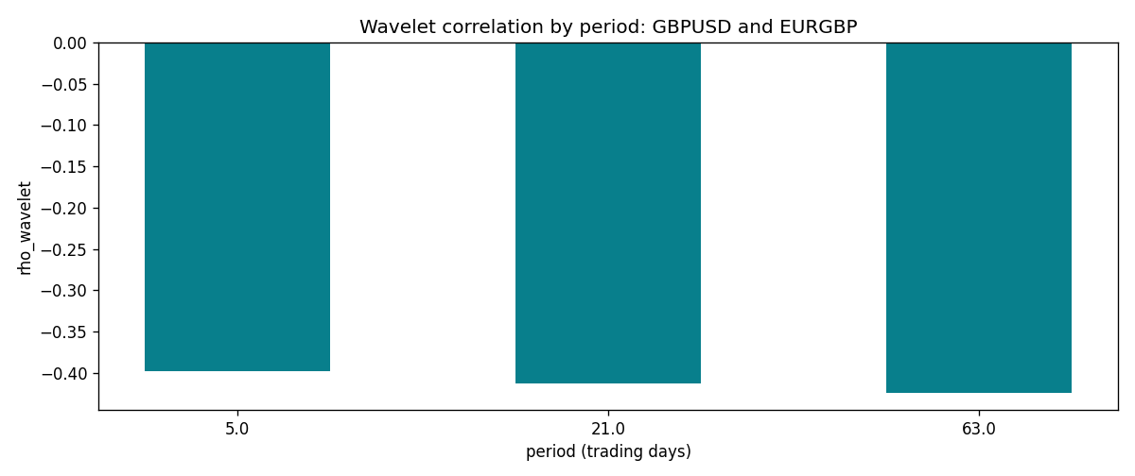

Data report
Matched rows and the scale sheet are in the sibling Excel workbook named GBPUSD-EURGBP_Wavelet_D1.xlsx. Embedding all rows as a Word table is impractical; this file holds column summaries and the first and last 15 matched rows.
Columns: time, GBPUSD_open, EURGBP_open, GBPUSD_high, EURGBP_high, GBPUSD_low, EURGBP_low, GBPUSD_close, EURGBP_close, GBPUSD_tick_volume, EURGBP_tick_volume, GBPUSD_spread, EURGBP_spread, GBPUSD_real_volume, EURGBP_real_volume, GBPUSD_log_return, EURGBP_log_return
Column summaries (matched calculation rows)
column | count | mean | std | min | 25% | 50% | 75% | max
GBPUSD_open | 7199 | 1.5160931 | 0.21831499 | 1.06854 | 1.324955 | 1.5114 | 1.63186 | 2.1066
EURGBP_open | 7199 | 0.78665041 | 0.09676322 | 0.5734 | 0.6873 | 0.83367 | 0.865175 | 0.9769
GBPUSD_high | 7199 | 1.5223838 | 0.21887686 | 1.08366 | 1.32978 | 1.5181 | 1.6384 | 2.1161
EURGBP_high | 7199 | 0.78972718 | 0.09713886 | 0.5789 | 0.68935 | 0.83657 | 0.86804 | 0.9799
GBPUSD_low | 7199 | 1.5097628 | 0.21753729 | 1.03518 | 1.3194 | 1.50323 | 1.62442 | 2.0983
EURGBP_low | 7199 | 0.78395066 | 0.09658082 | 0.5682 | 0.6853 | 0.83147 | 0.862765 | 0.9661
GBPUSD_close | 7199 | 1.5161471 | 0.21826306 | 1.06879 | 1.325055 | 1.51122 | 1.63216 | 2.1065
EURGBP_close | 7199 | 0.78669405 | 0.09676312 | 0.5735 | 0.6875 | 0.8337 | 0.86528 | 0.977
GBPUSD_tick_volume | 7199 | 94850.986 | 153561.38 | 62 | 9998.5 | 52911 | 91818.5 | 1273370
EURGBP_tick_volume | 7199 | 86949.029 | 145390.09 | 154 | 6517.5 | 44265 | 81326 | 1424684
GBPUSD_spread | 7199 | 26.96055 | 19.19062 | 0 | 11 | 20 | 50 | 50
EURGBP_spread | 7199 | 21.393666 | 19.14328 | 0 | 4 | 13 | 50 | 50
GBPUSD_real_volume | 7199 | 3.5570778e+09 | 8.4449923e+10 | 0 | 0 | 0 | 0 | 2.4038164e+12
EURGBP_real_volume | 7199 | 2.7805214e+10 | 1.3507095e+11 | 0 | 0 | 0 | 0 | 3.5726265e+12
GBPUSD_log_return | 7199 | -3.133e-05 | 0.00564236 | -0.08388241 | -0.00313644 | 2.978e-05 | 0.00317207 | 0.03112653
EURGBP_log_return | 7199 | 2.179e-05 | 0.00487166 | -0.03067367 | -0.0026225 | -0.00010035 | 0.00256076 | 0.06075387
First 15 matched rows (selected columns)
time | GBPUSD_log_return | EURGBP_log_return
1999-01-06 | -0.00060452184 | -0.013303338
1999-01-07 | -0.002118709 | 0.011051402
1999-01-08 | -0.0058954193 | -0.004943862
1999-01-11 | -0.0056851331 | -0.0012752393
1999-01-12 | 0.0022657001 | 0.0033970309
1999-01-13 | 0.0091330396 | 0.00042381861
1999-01-14 | 0.0019376331 | -0.0019793588
1999-01-15 | -0.0017558204 | -0.0076715819
1999-01-18 | 0.0012112405 | 0.00071280921
1999-01-19 | 0.0018745281 | -0.0014261269
1999-01-20 | -0.0049053846 | 0.0019960086
1999-01-21 | 0.0031518998 | -0.00071240297
1999-01-22 | 0.0024781662 | -0.0017118406
1999-01-25 | 0.0012066366 | -0.0054402425
1999-01-26 | 0.00072328374 | -0.00057438255
Last 15 matched rows (selected columns)
time | GBPUSD_log_return | EURGBP_log_return
2026-10-13 | 0.0036434319 | 0.00020130374
2026-10-14 | -0.0049164679 | 0.0011241873
2026-10-15 | 0.0065976411 | -0.00087557391
2026-10-16 | 0.0037592051 | -0.0020380844
2026-10-19 | -0.0017500314 | -0.00056950988
2026-10-20 | 0.0055923442 | -0.0035906254
2026-10-21 | 0.0012476328 | -0.00140647
2026-10-22 | 0.00022396082 | -0.0018743924
2026-10-23 | -0.0021146949 | 0.00082421033
2026-10-26 | -0.0024340661 | 0.00013133309
2026-10-27 | -0.0023648393 | -0.0019957343
2026-10-28 | 0.0015771808 | 0.00066967224
2026-10-29 | 0.0035881935 | -0.0011722209
2026-10-30 | 0.0013450605 | -0.0024205543
2026-11-02 | 0.0010971256 | 0.00089940465

